Zachary Weiss

ME570 HW2

Professor Tron

5 October 2020

*Q1.1*:

1. R1(θ) represents a 2-D CCW rotation on the x2 x­3 plane.
2. R2(θ) represents a 2-D CCW rotation on the x1 x­3 plane.
3. R3(θ) represents a 2-D CCW rotation on the x1 x­2 plane.
4. R4(θ) represents a 2-D CCW rotation on the x1 x­2 plane, which is then negated (in other words, an additional π rad CCW atop the theta input).

*Q2.1*:

1. and

*Q2.2*:

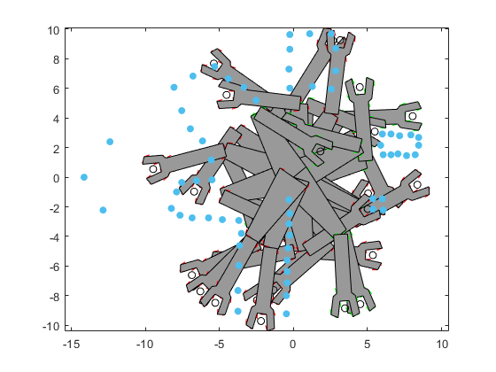

*Q4.1*: